|  |  |  |  |  |
| --- | --- | --- | --- | --- |
| |  |  | | --- | --- | | CodeNoob |  | |  |  | |
| CodeNoob Appendix  The following is an appendix about the "CodeNoob" project |

# Website introduction

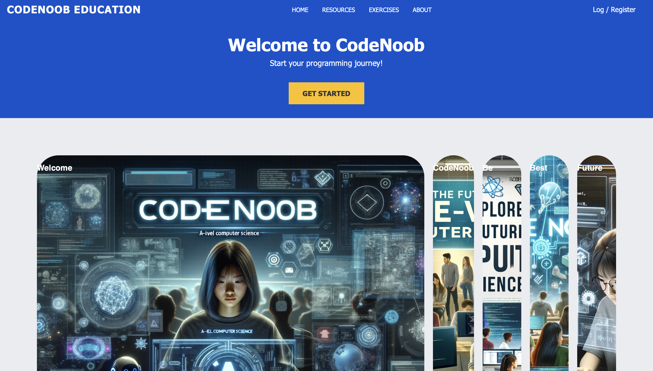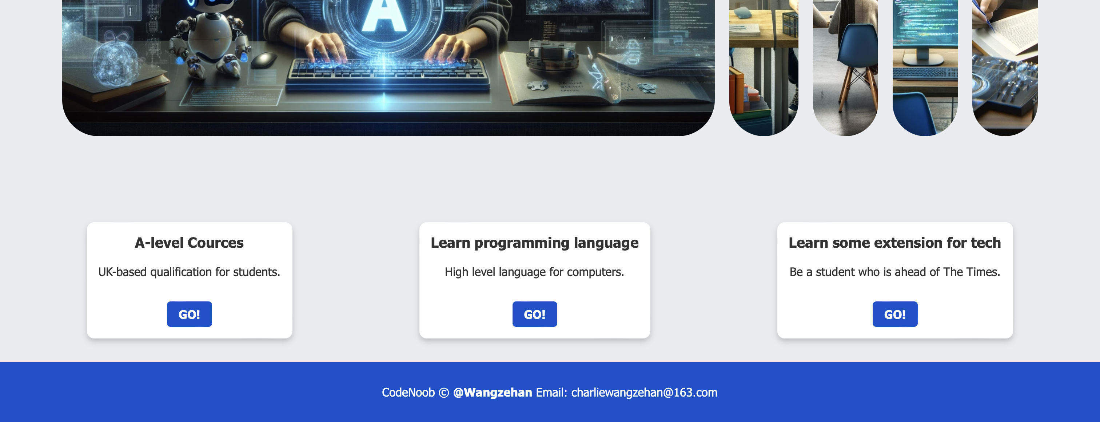

## Home page

The site's homepage features five images created by generative AI, made into an accordion-style pull-out effect that showcases futuristic technology.

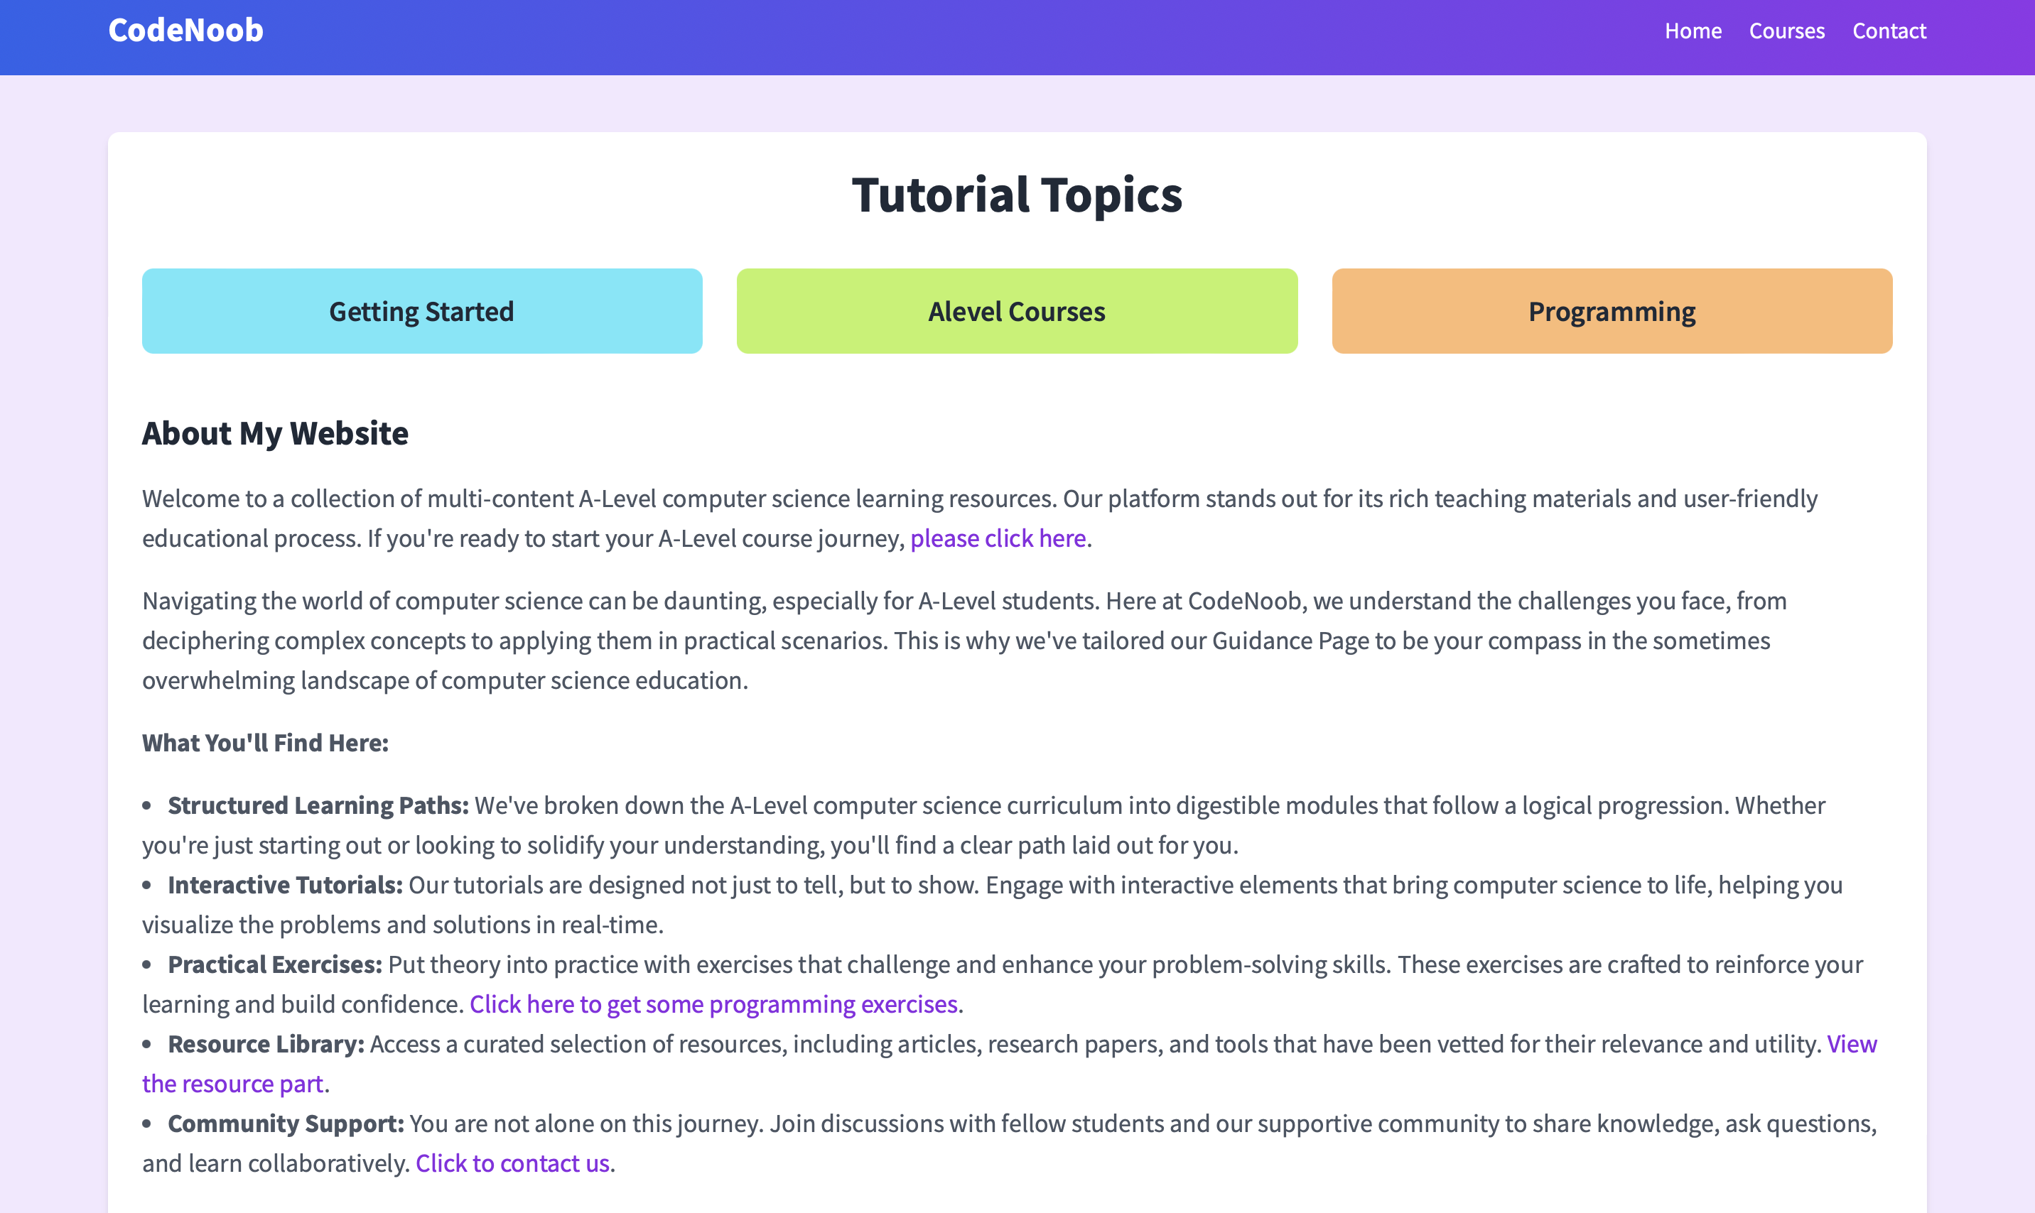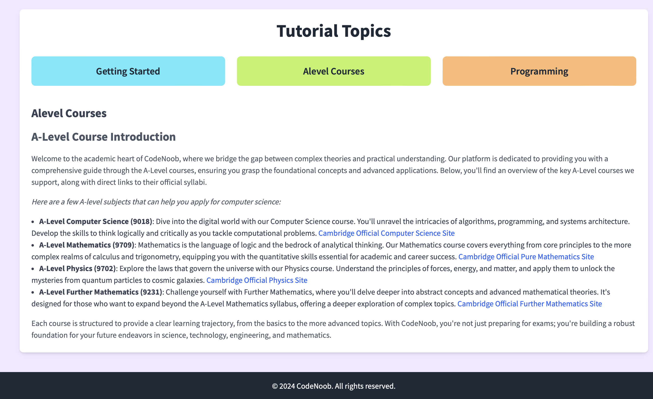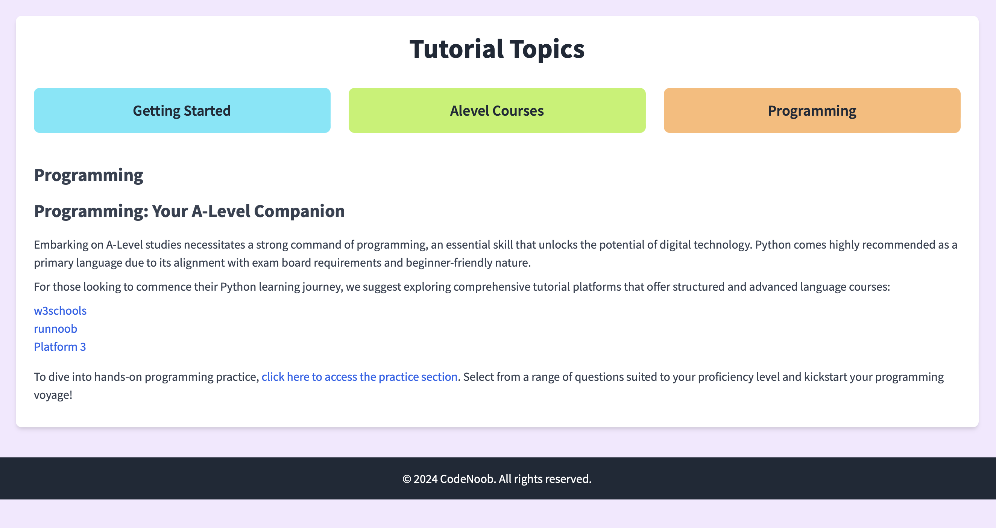

## Introduction and guidance

The purpose of the site is briefly stated here, as well as being clickable to all other pages.

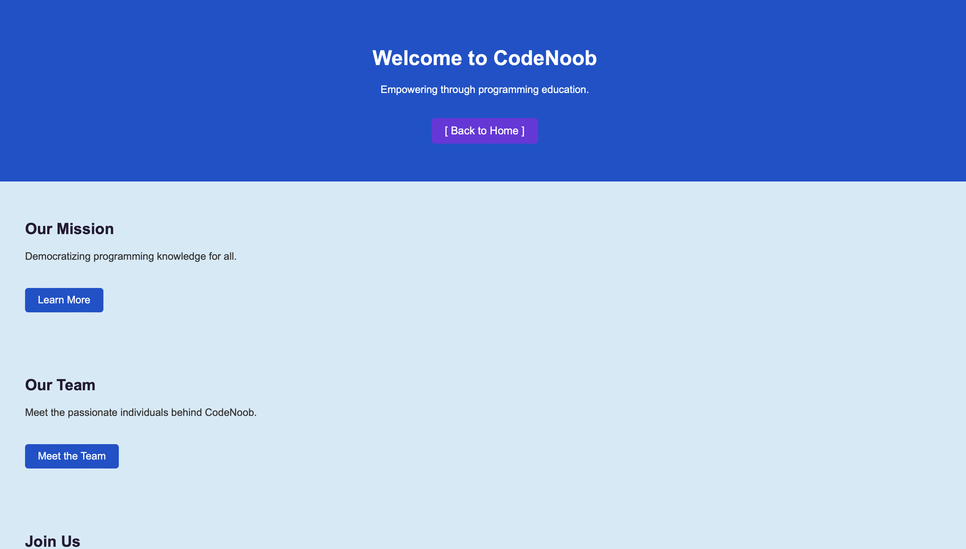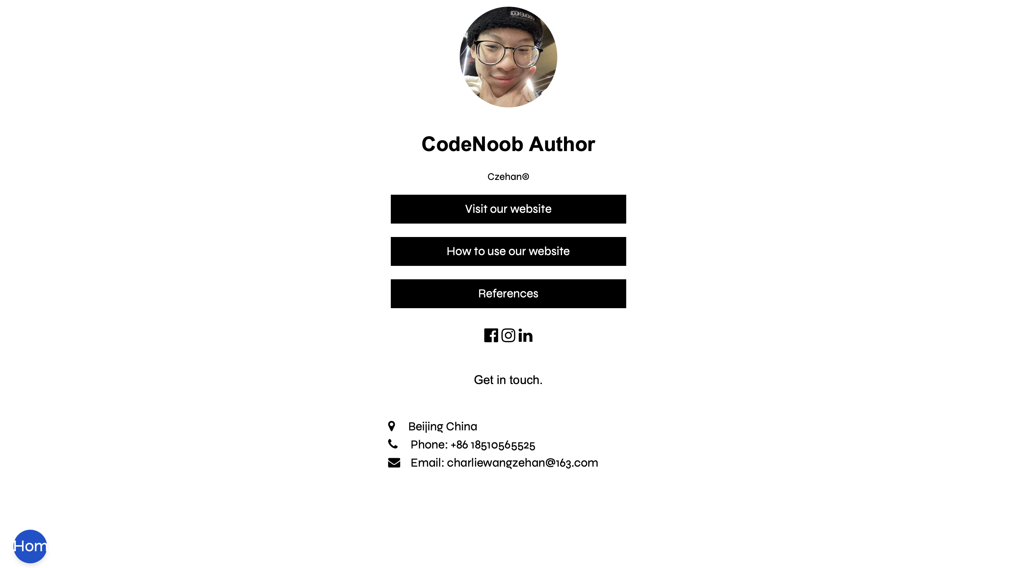

## About us

Here is a description of all the background resources on the site and how the author practiced.

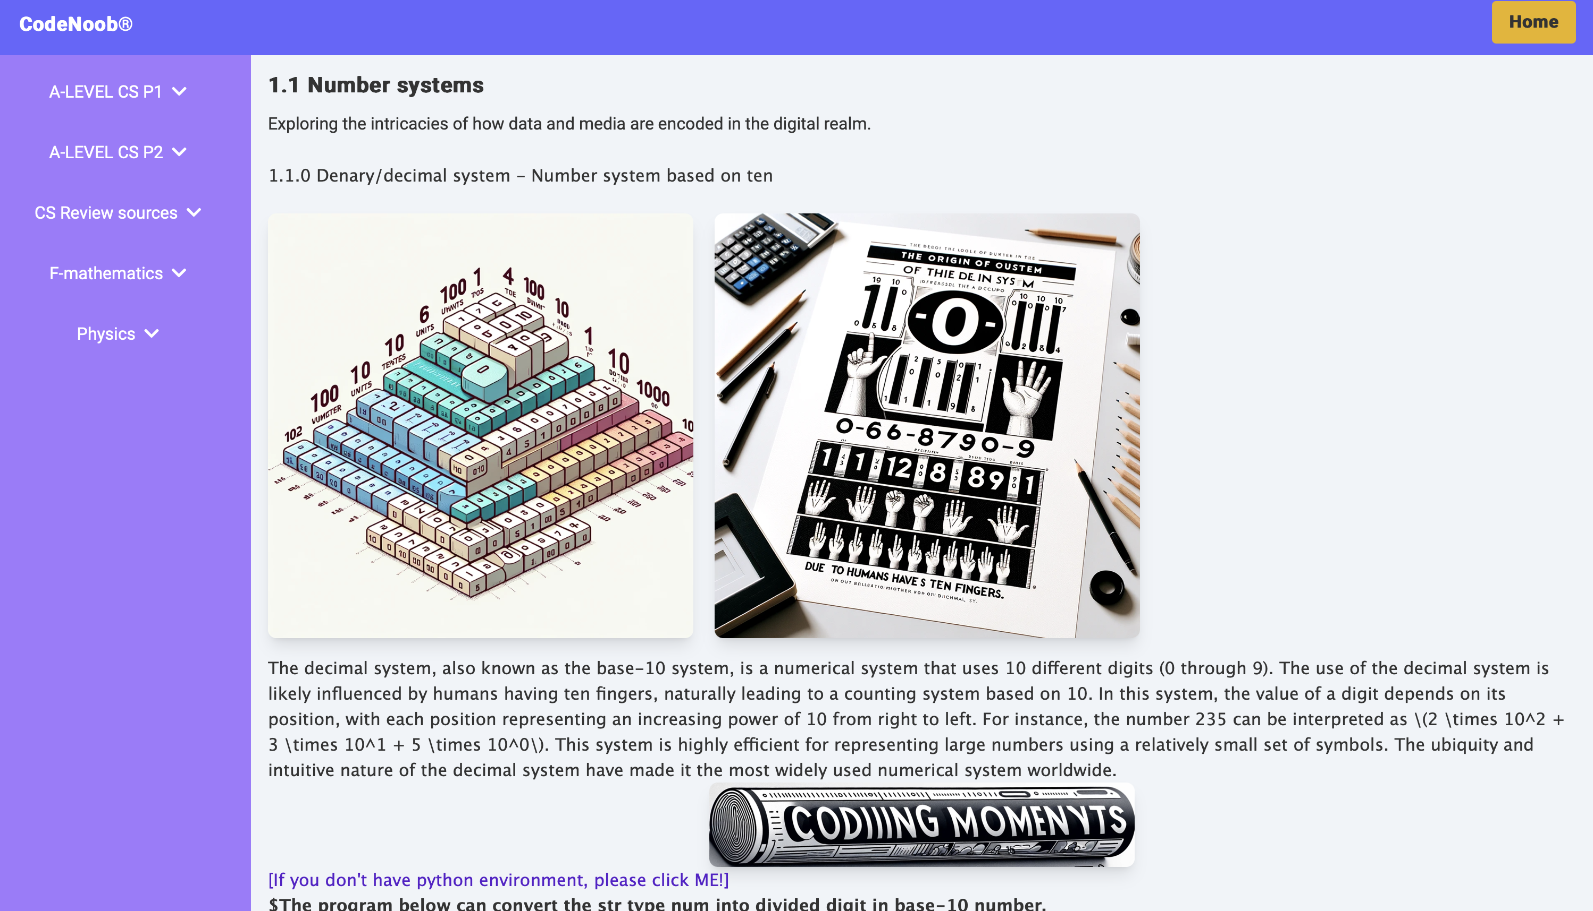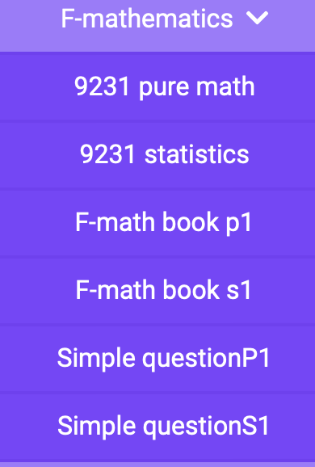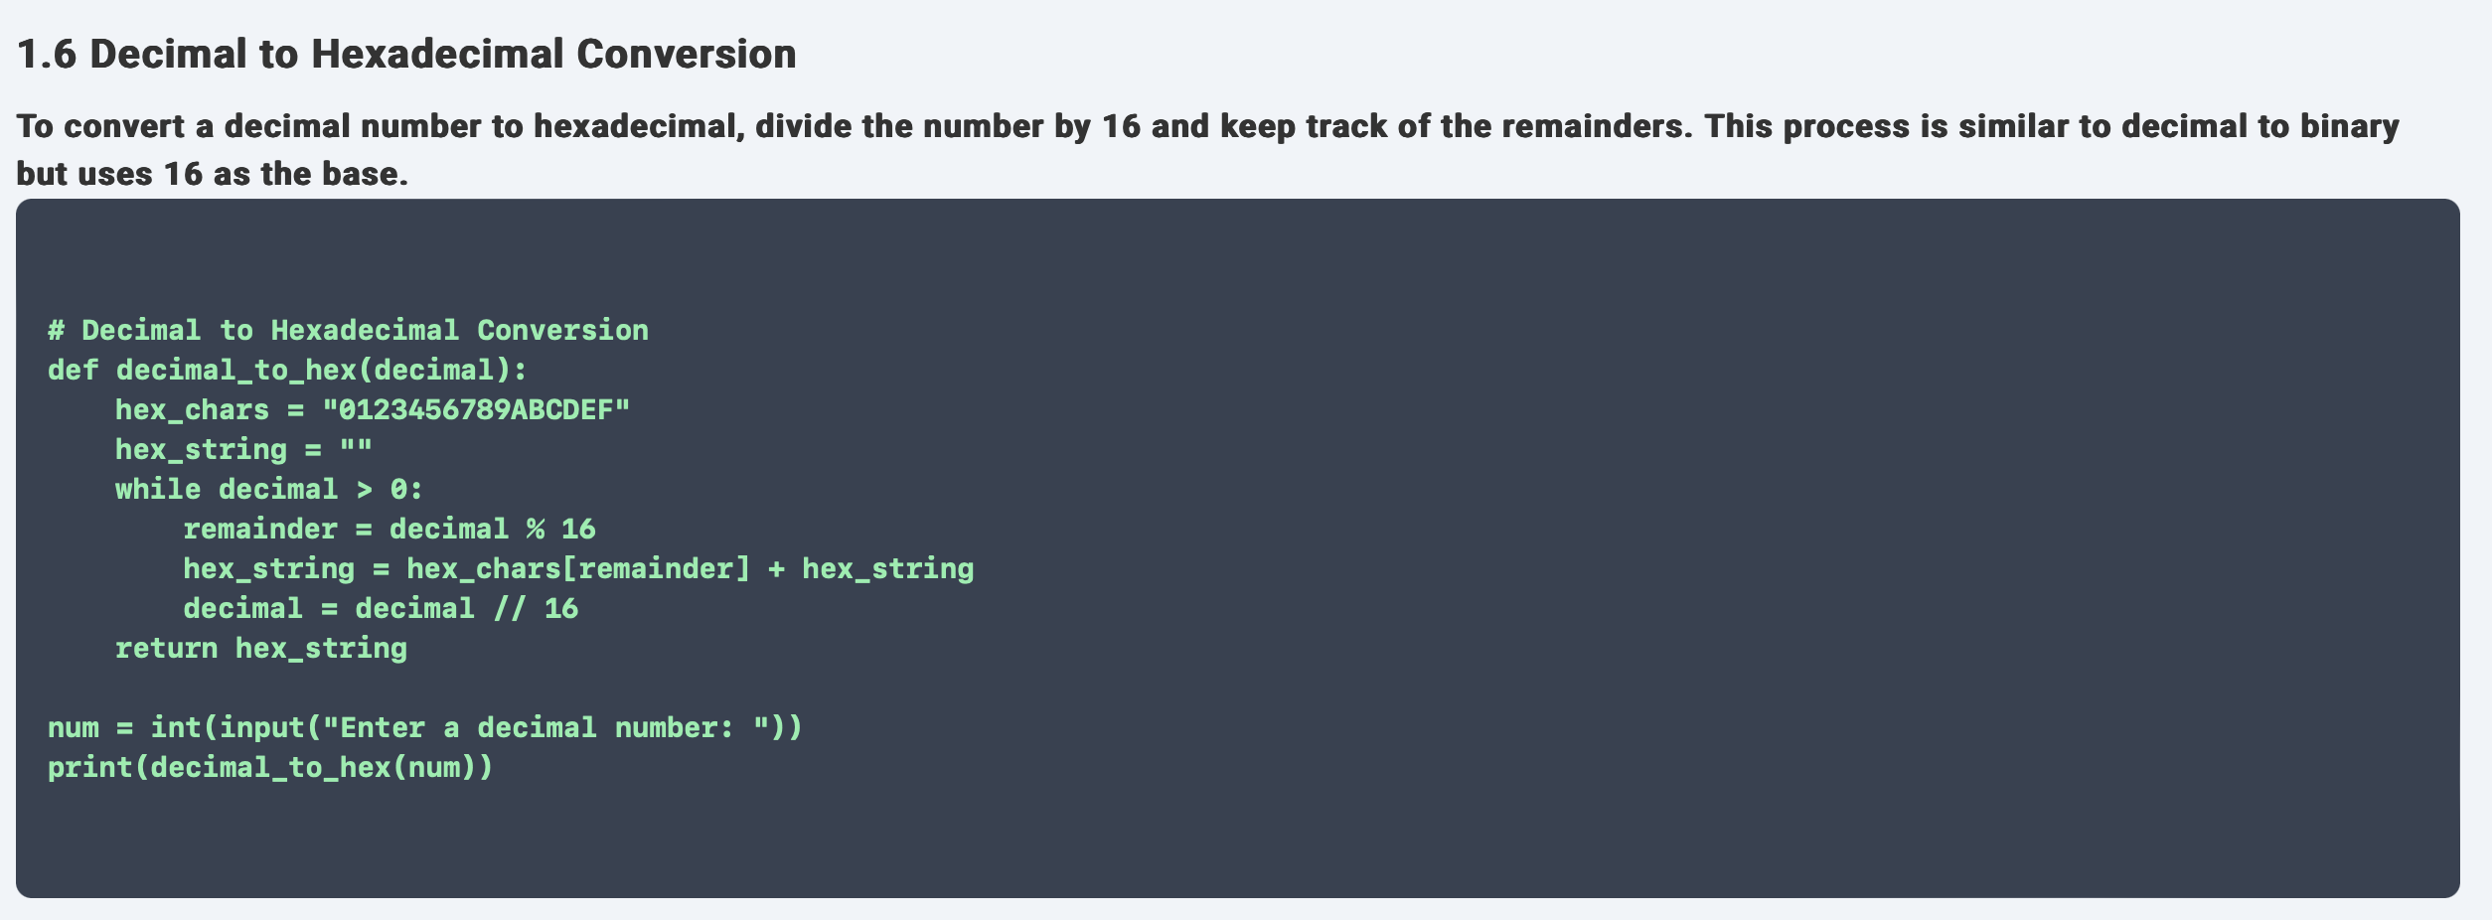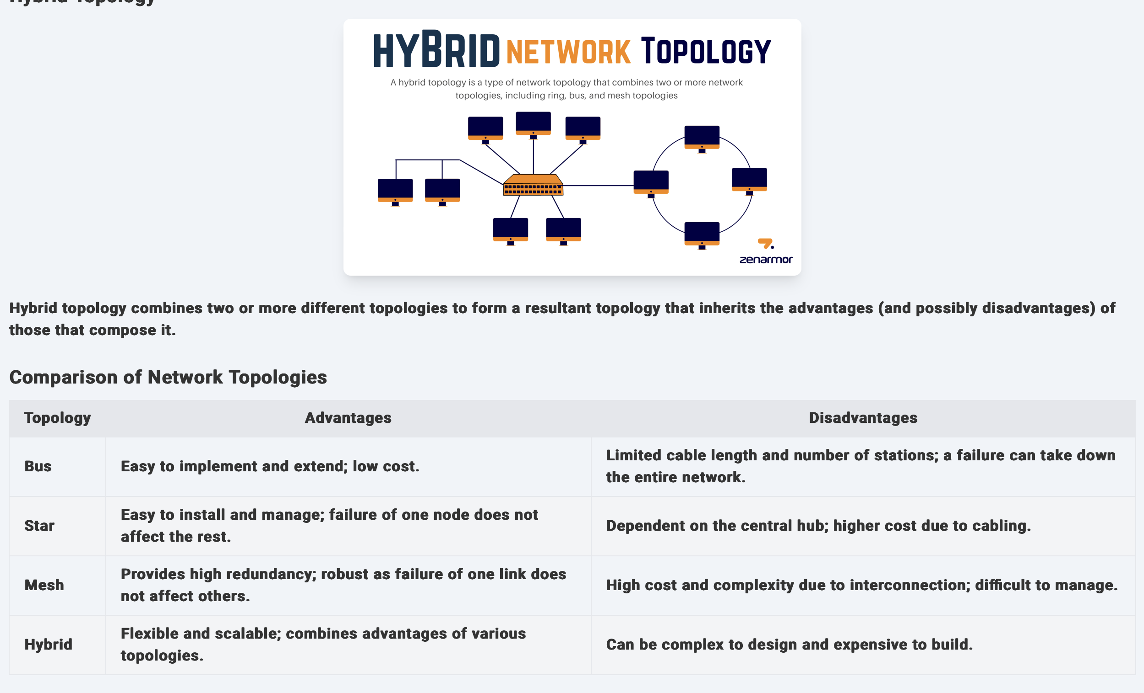

## A-level Courses teaching

A collection place for detailed explanations of specialized A-level courses as well as resources and more for each subject.

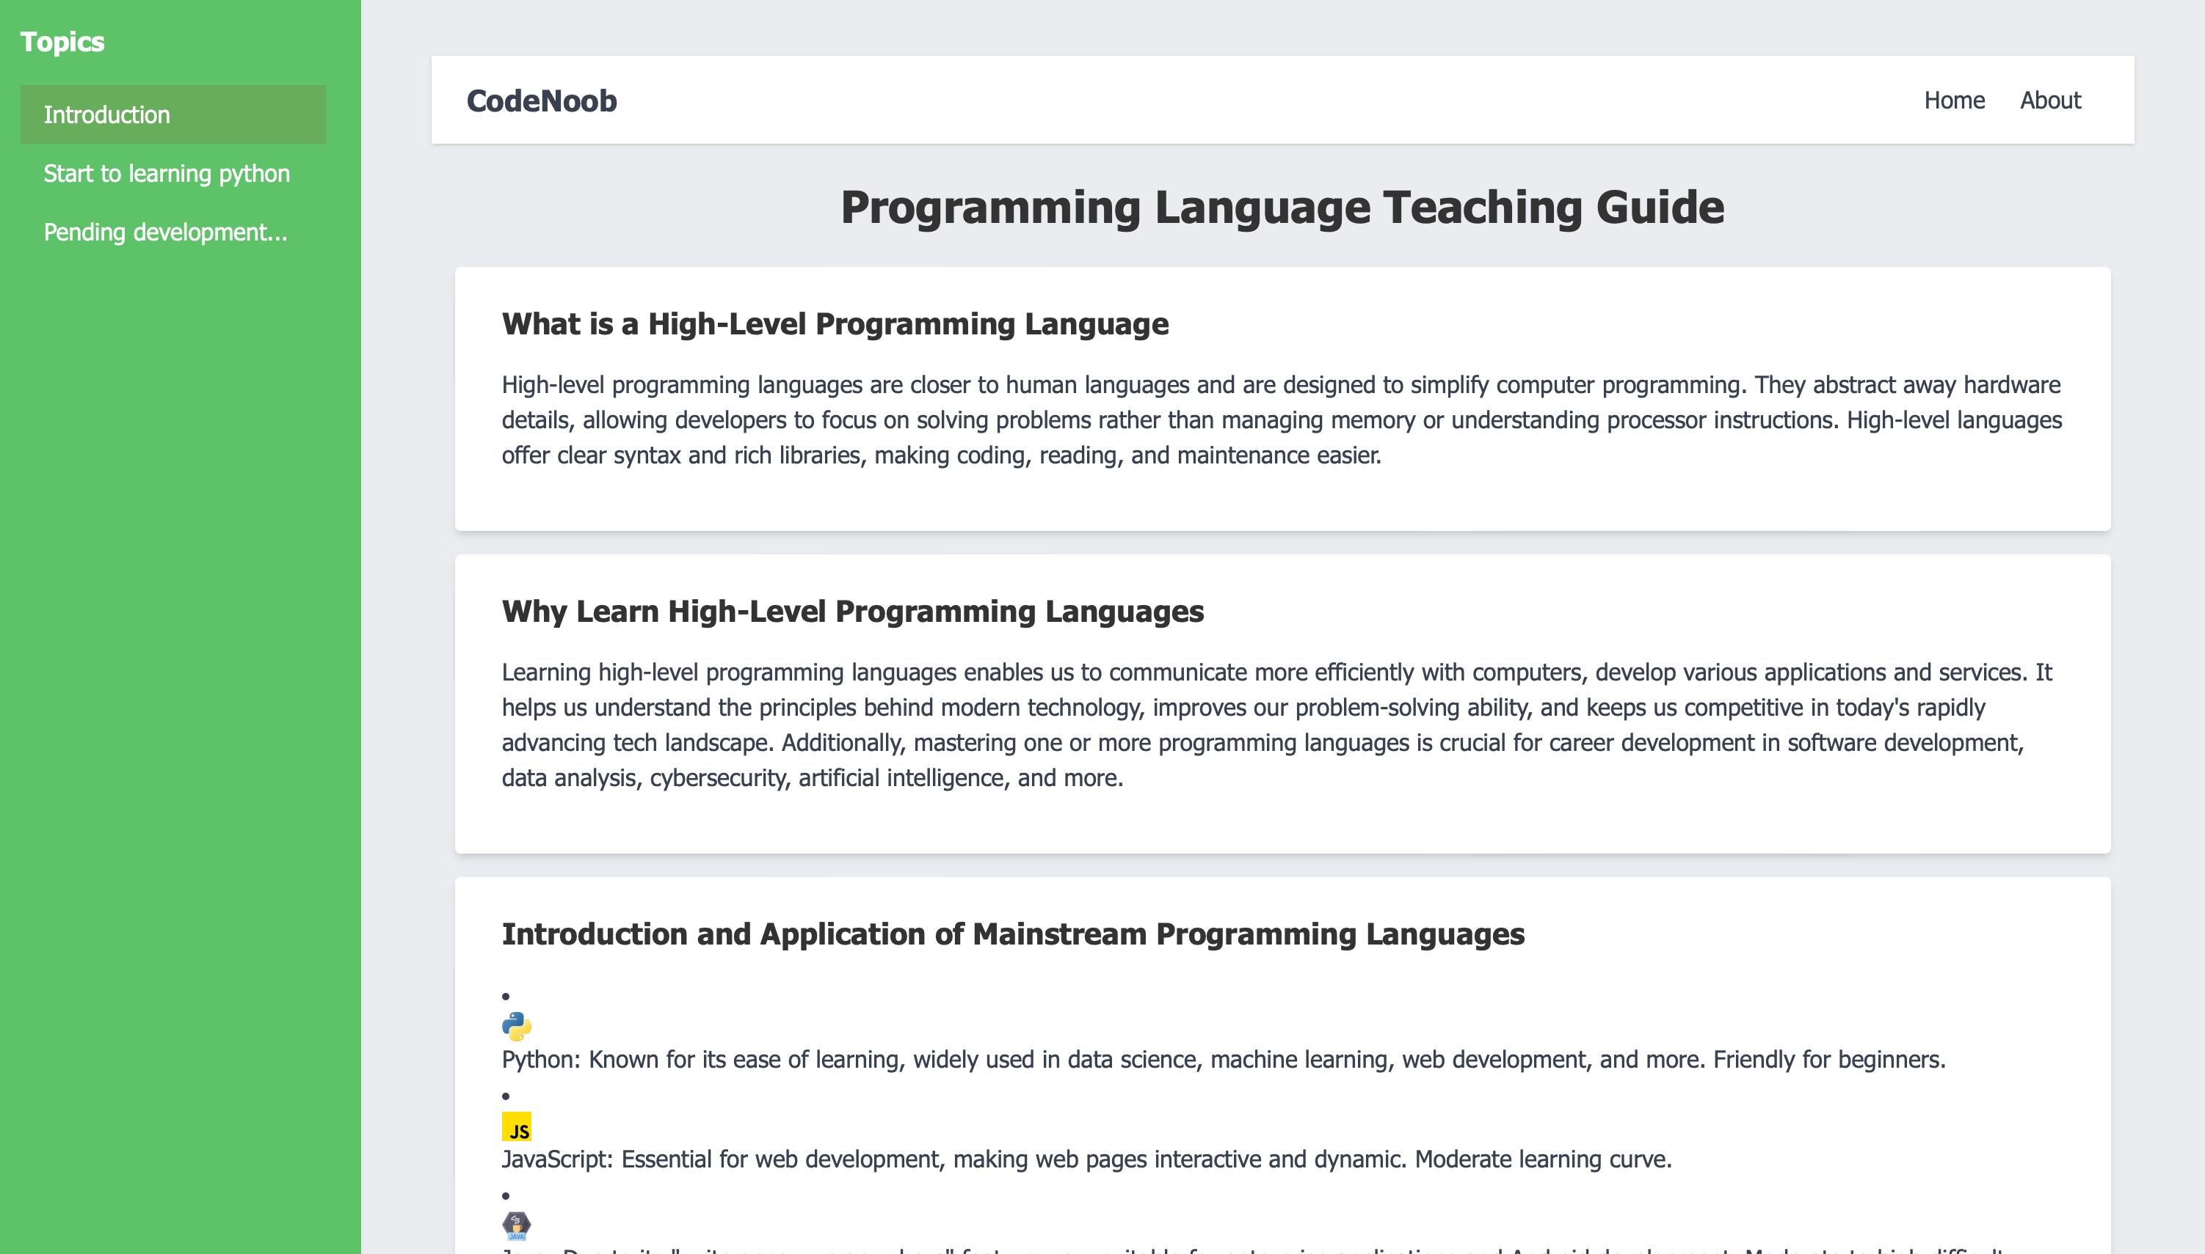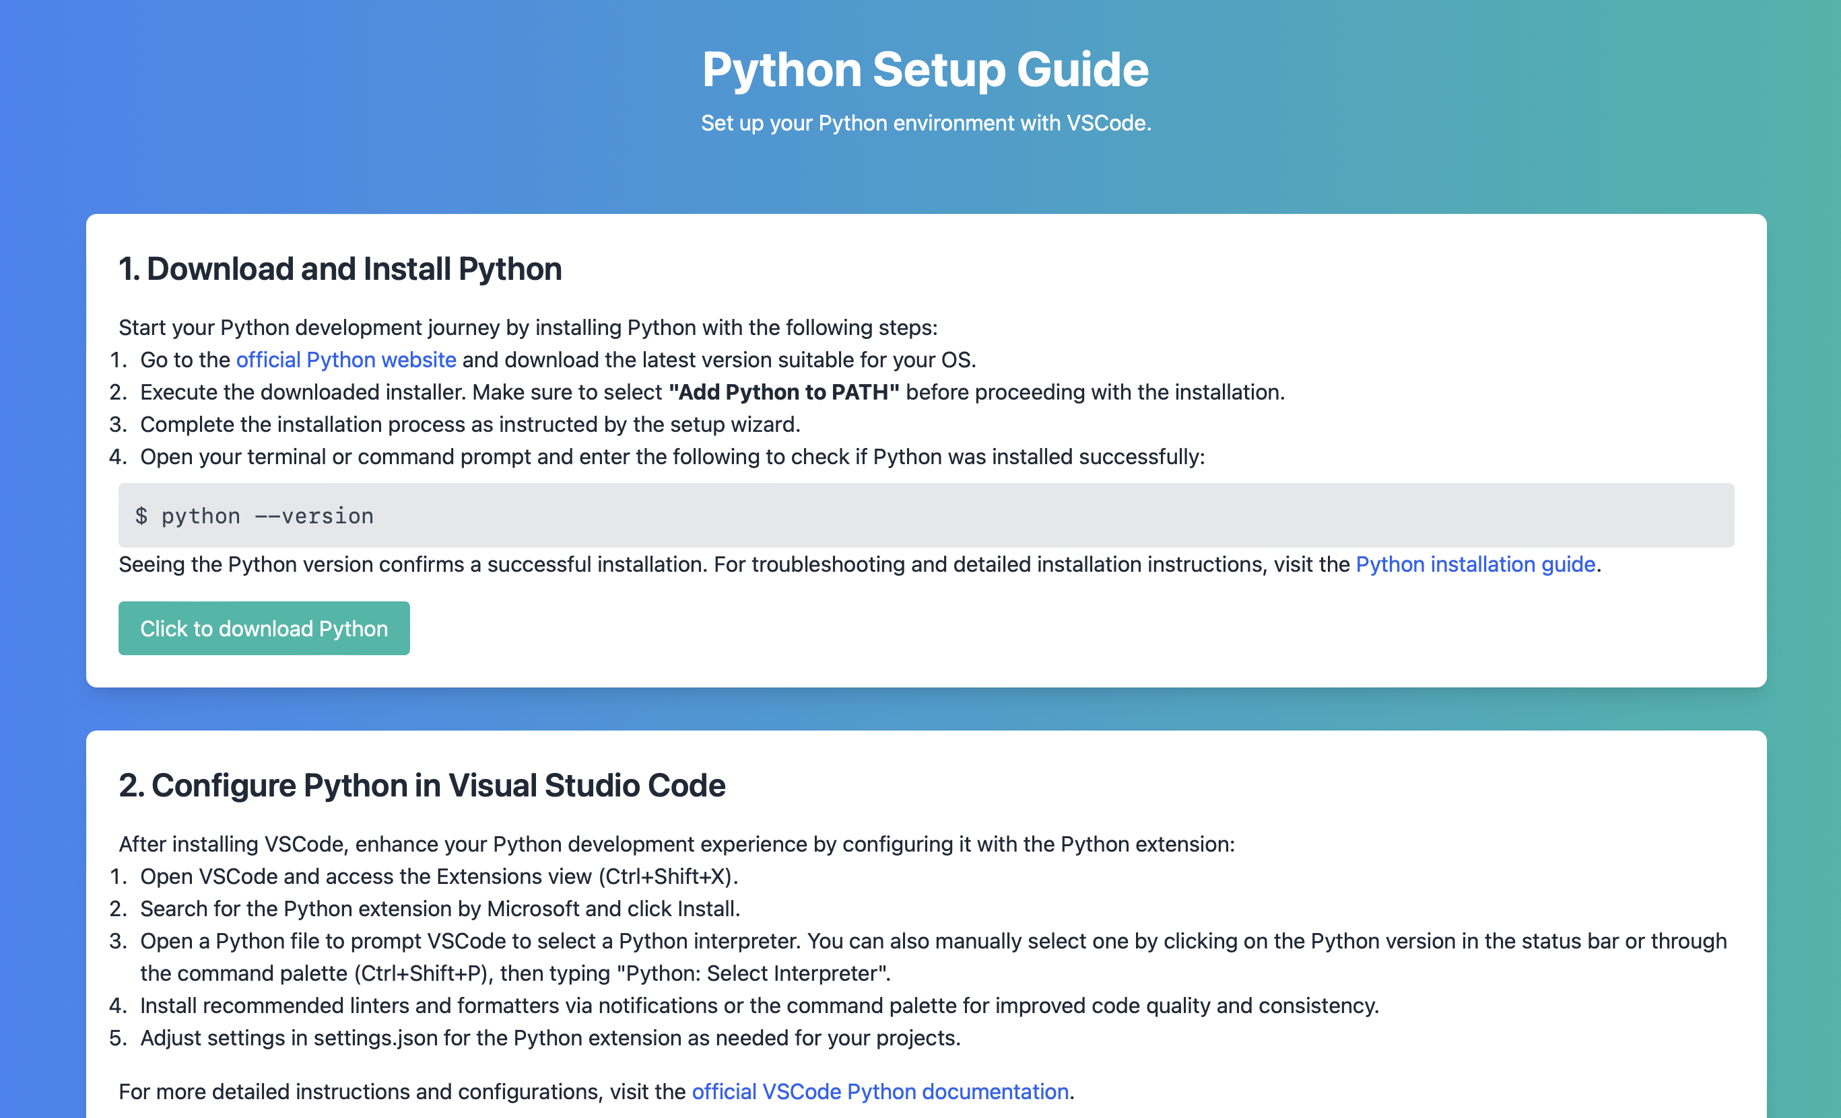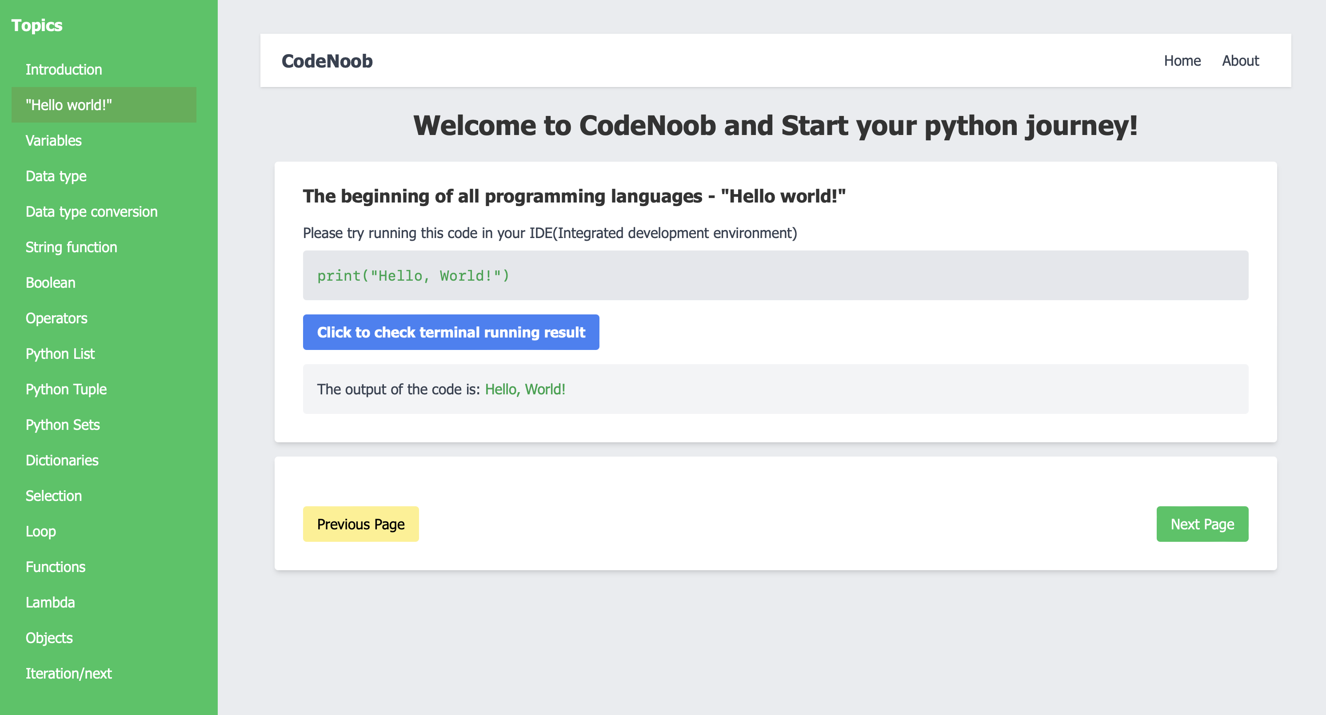

## Teaching Programming Languages

CodeNoob's original approach to teaching programming languages is offered here, understanding students from the ground up and teaching them.

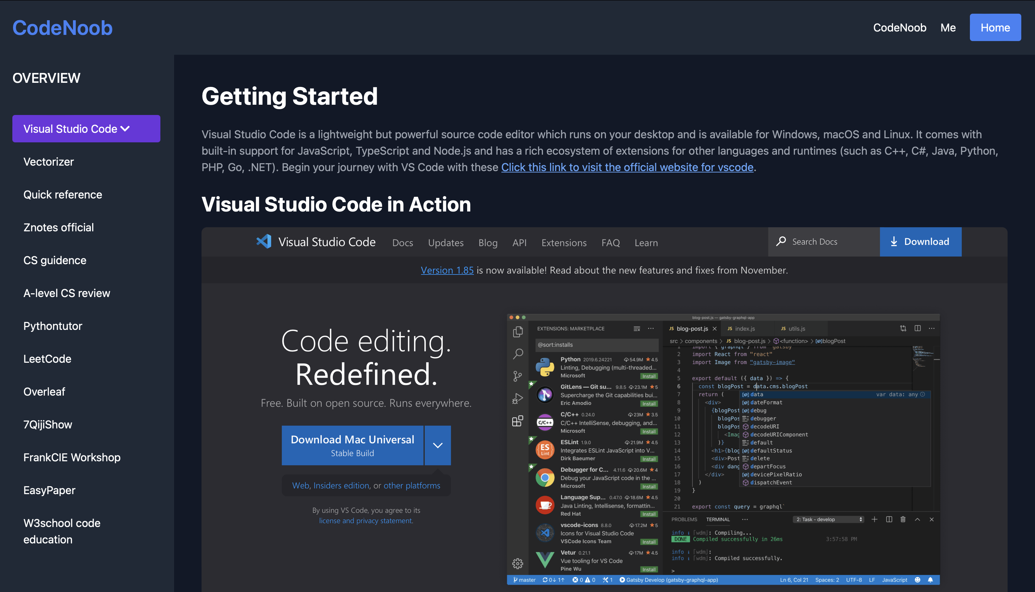

## Resource sharing component

Recommendations for good software sites for learning computer science are all here, hands down.

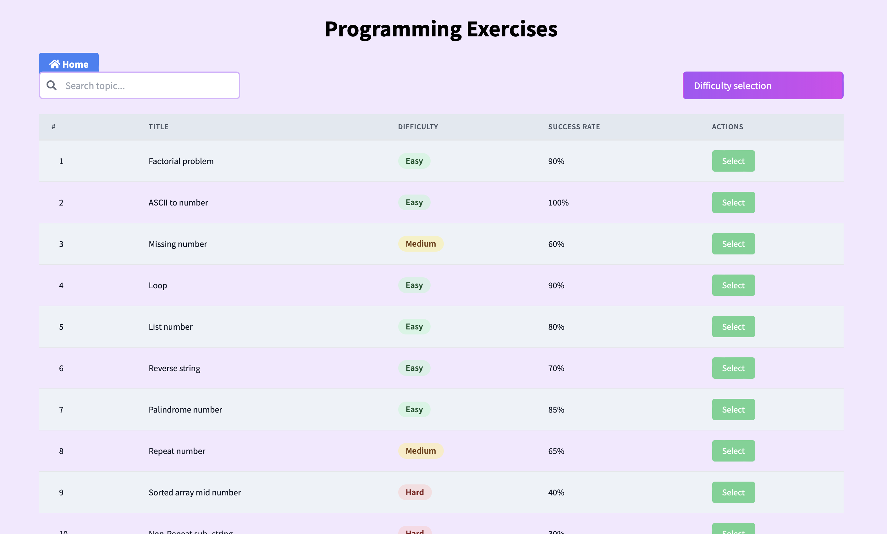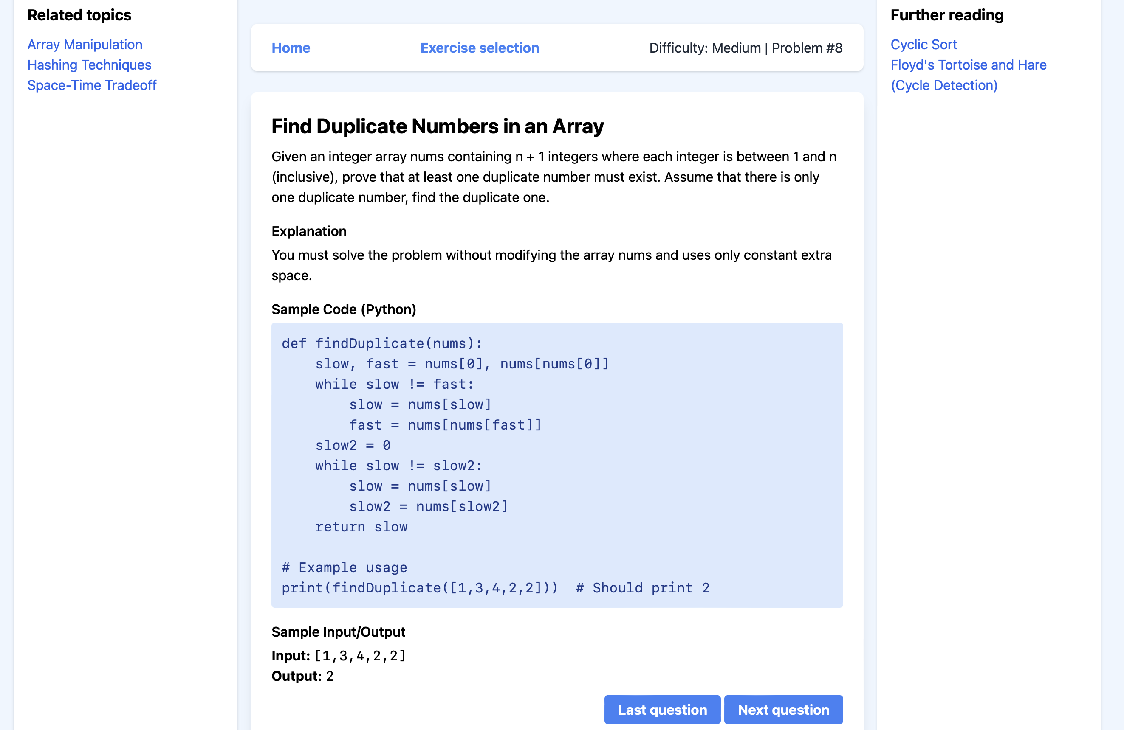

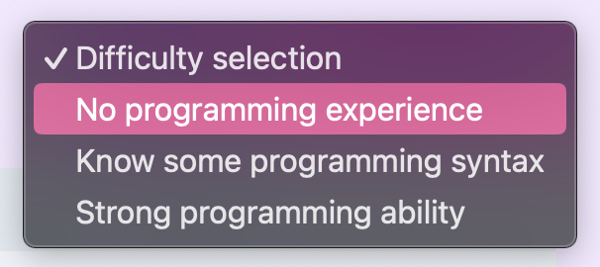

## Programming exercise section

The topics available for difficulty selection and filtering can be practiced, and after practicing all the programming puzzles can be solved at the level of difficulty required for mastery of most A-level computer science.

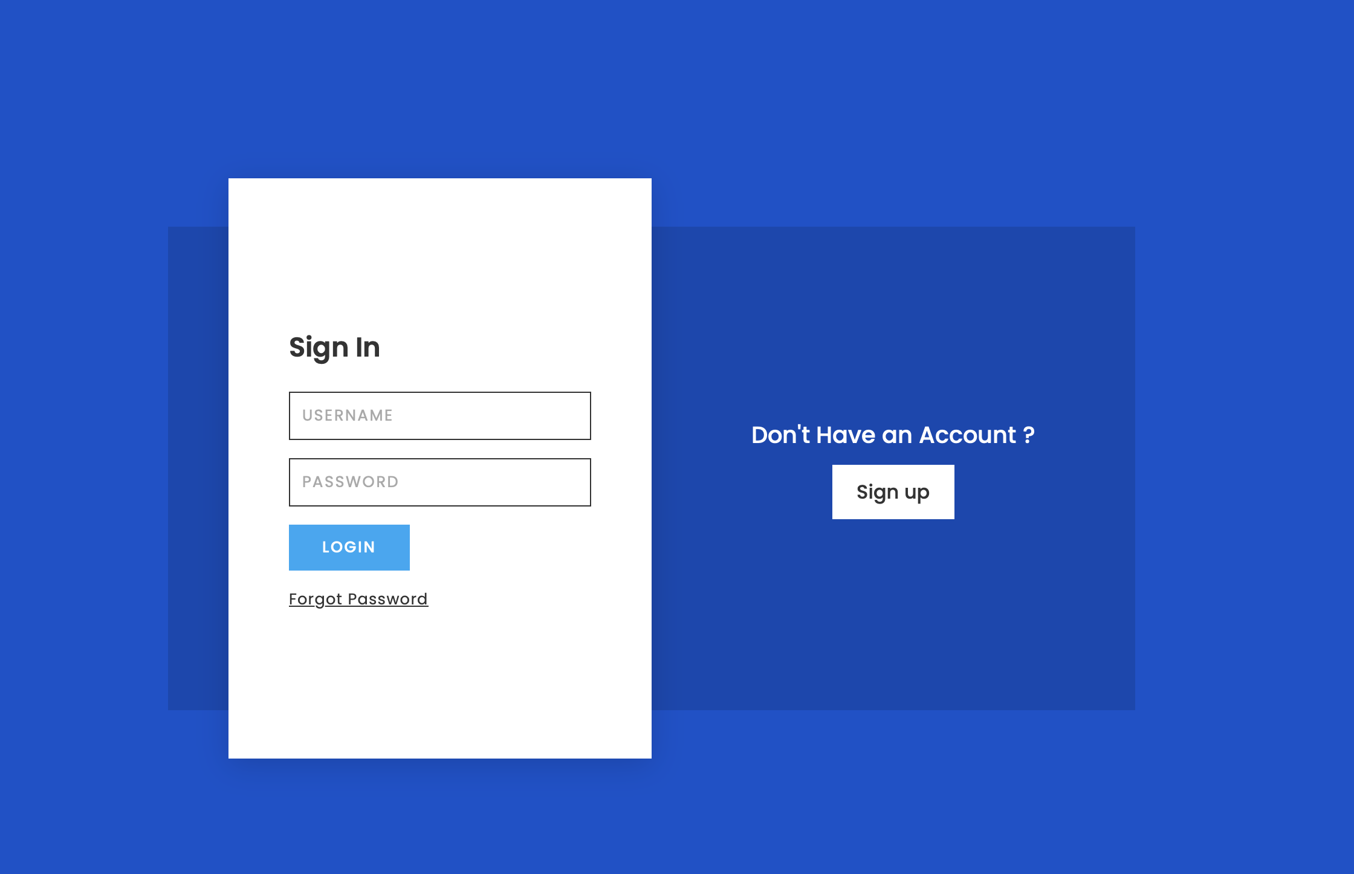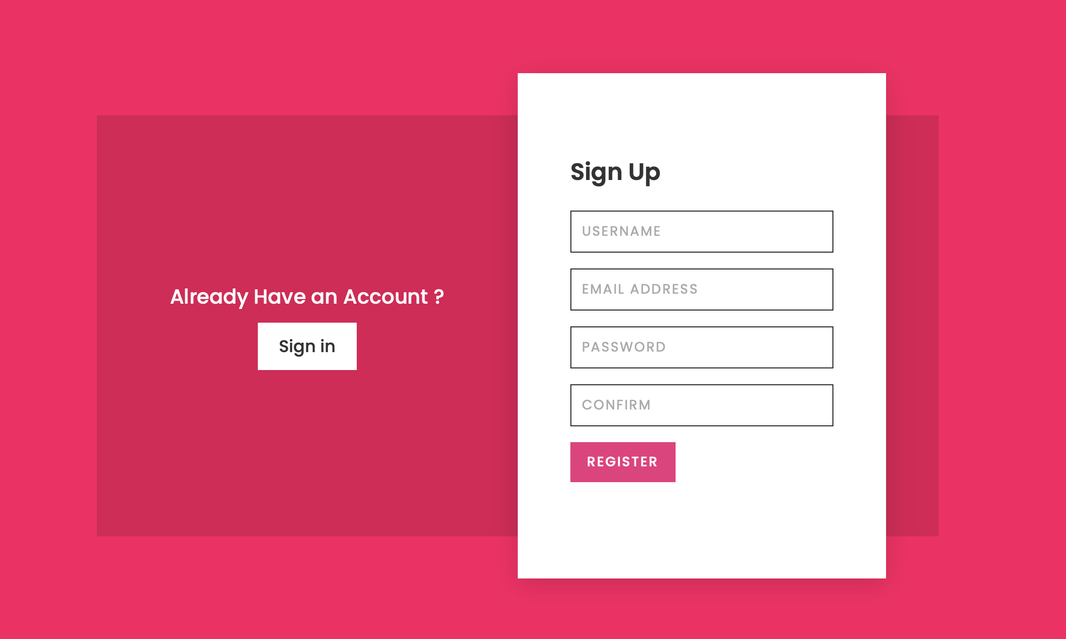

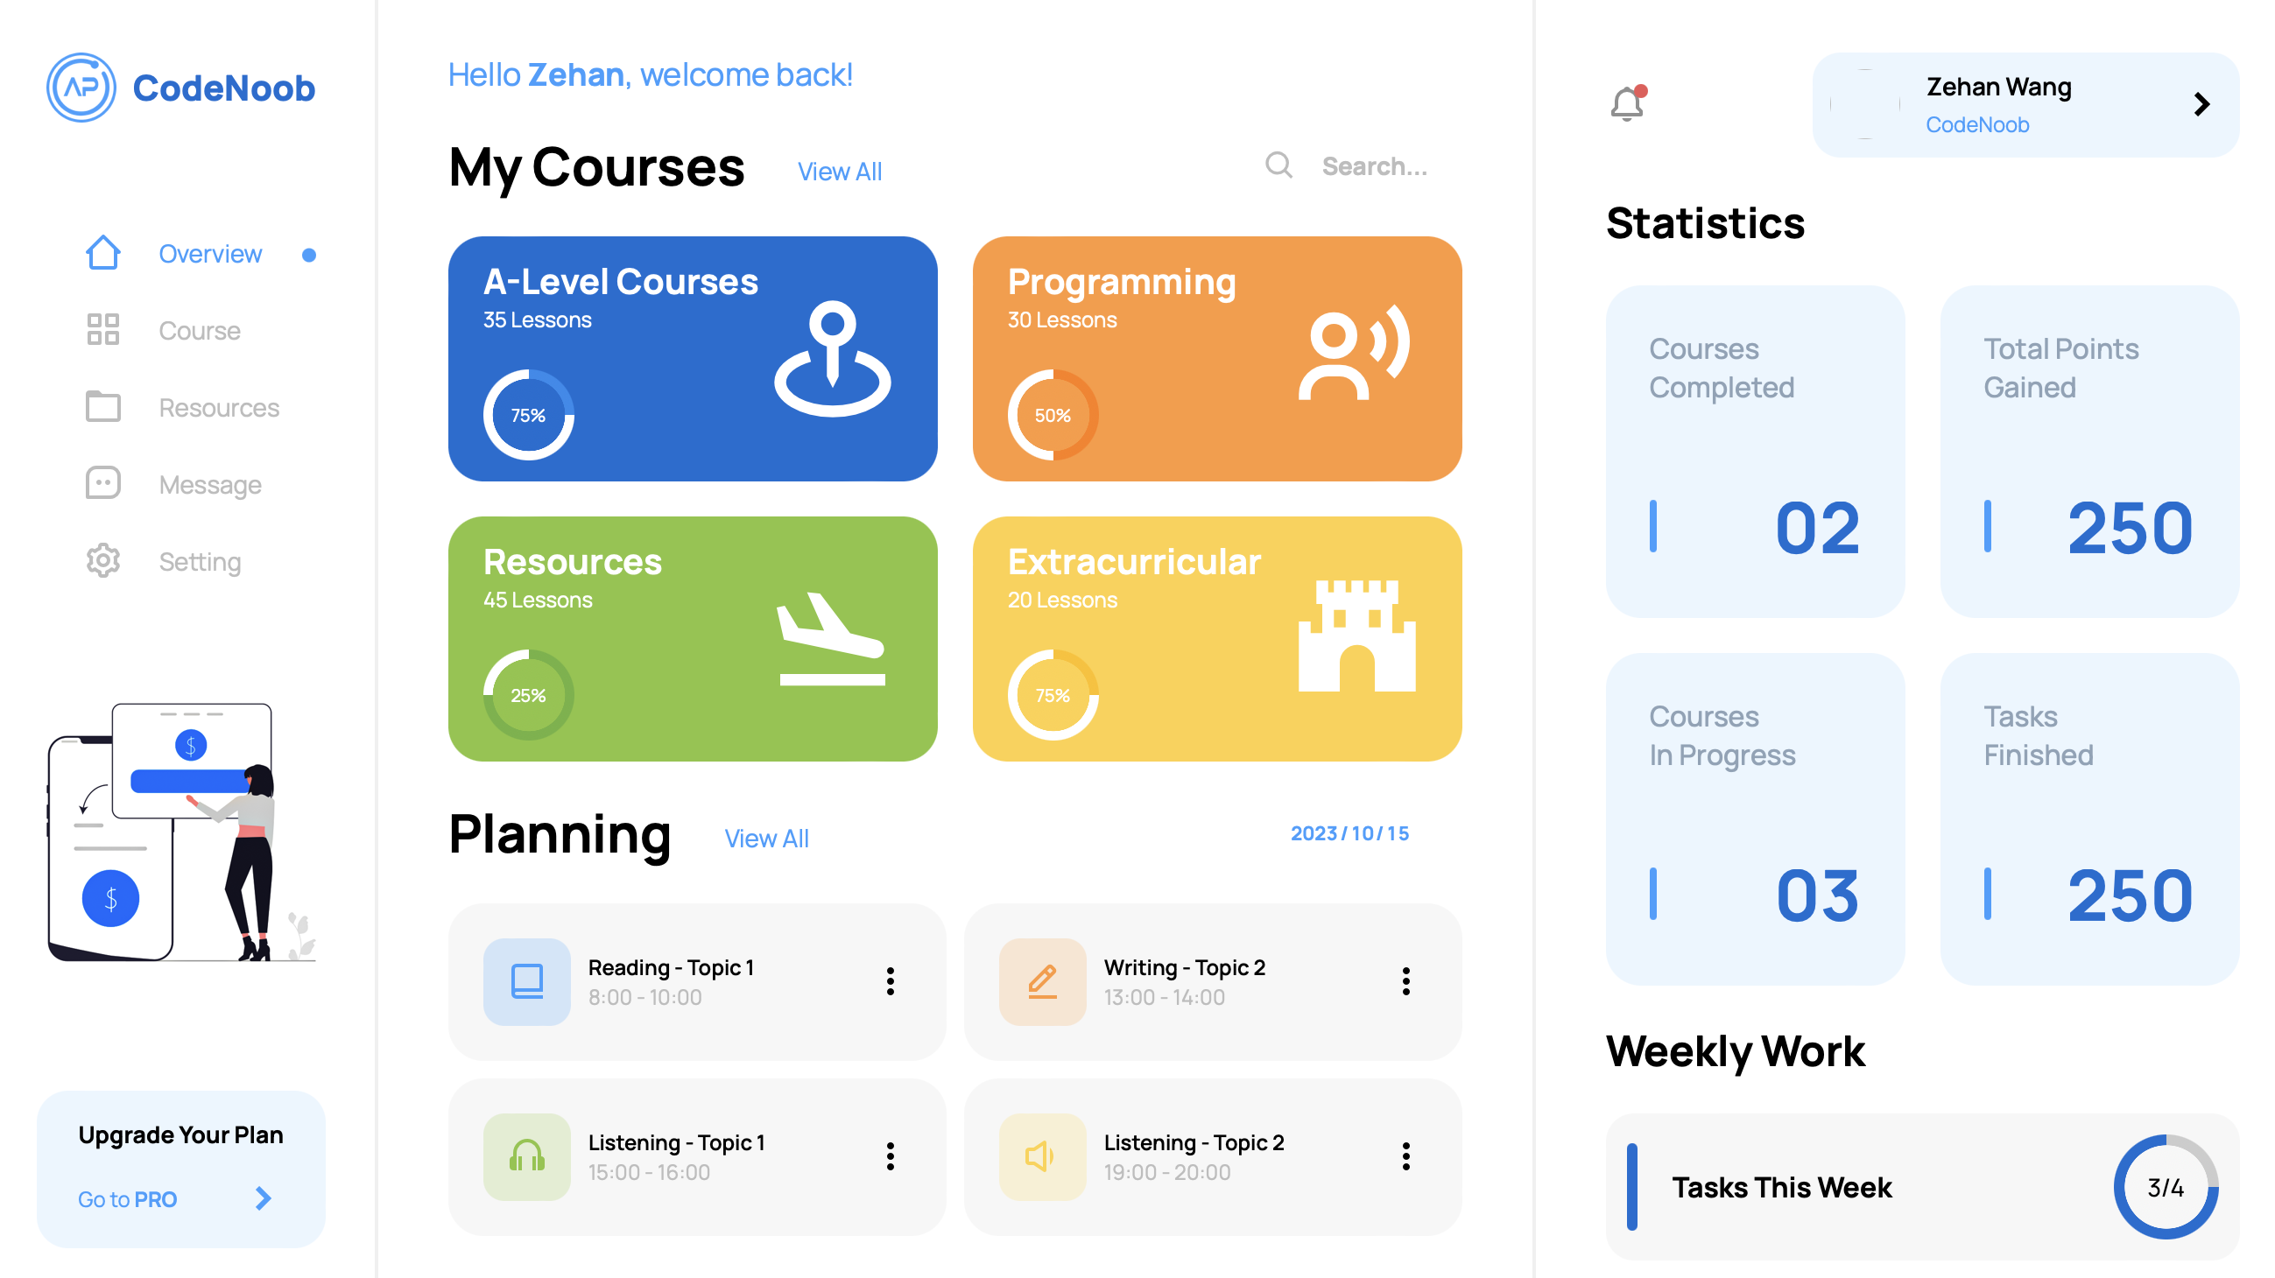

## Personal customization

Log in to take advantage of the course scheduling planner service.

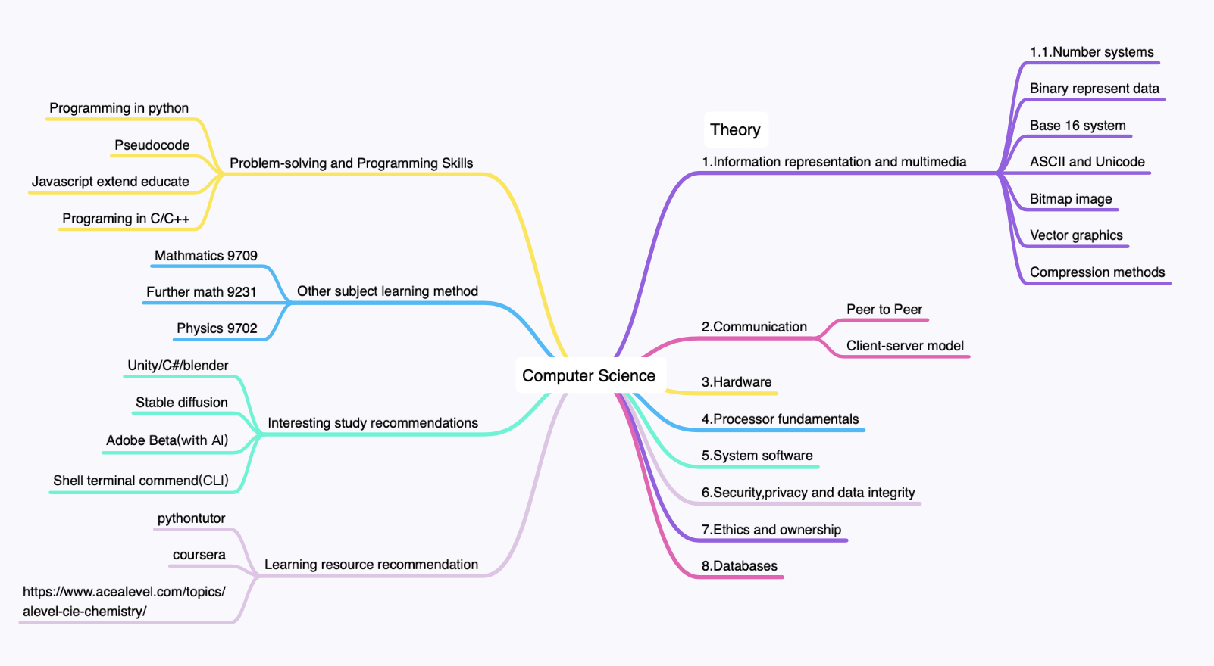

## Website planning mind map

## 

## Gantt chart

# Link to introductory video

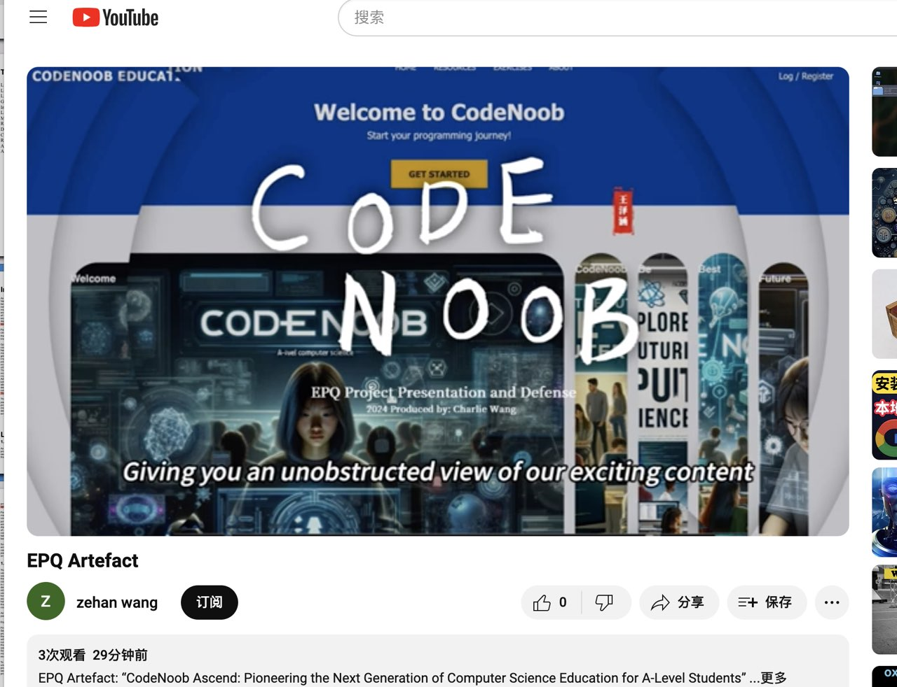

## YouTube URL

<https://youtu.be/flhoG_o8z-4?feature=shared>

# Source code and task files

## Google cloud drive

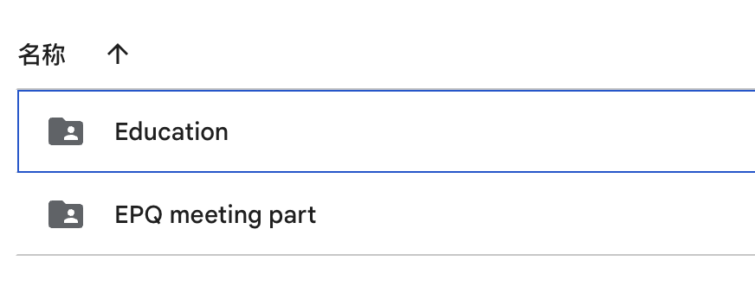

Website source code:

<https://drive.google.com/drive/folders/1VyZruUDoeOBpSaqAtGcfzqMKPaV7Wa0S?usp=drive_link>

Conference PPT and documents:

<https://drive.google.com/drive/folders/1IXr3mQJtImw_tz4YTyAnEYd3s3mAVB0r?usp=drive_link>